Code Craft Learning
HTML: Frontend Fundamentals Assessment
Student Name: __________________________ Date: _________________
Assessment Overview
This assignment is designed to evaluate students who have successfully completed the Frontend HTML module. The purpose is to assess understanding of core HTML concepts, including page structure, semantic elements, forms, links, media, and layout creation. Students must apply their knowledge of HTML fundamentals.
Instructions
- Read each question carefully.
- Choose the correct option.
- Do not modify the questions.

Question 1: What does width=device-width mean in the viewport meta tag?
A) Sets the width of the webpage to a fixed 1000px
B) Sets the width of the webpage equal to the device screen width
C) Sets the height of the webpage equal to device height
D) Sets the browser height to full screen
Answer:

Question 2: What are Semantic HTML elements?
A) Elements used for styling only
B) Elements that give meaning to the content
C) Elements used for images
D) Elements used for links
Answer:

Question 3: Spot the Syntax Error. Which of these form elements will cause issues with ID/Class standards?
A) <input type="text" class="form-control login-input">
B) <button id="submitBtn" class="primary-btn">Submit</button>
C) <form id="userForm" id="mainForm">
D) <label class="main-label">Username</label>
Answer:

Question 4: What is the "main problem" with this form?

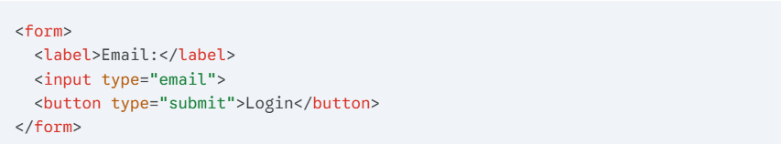

A) The form has no button.
B) The inputs are not inside a <div>.
C) The input is missing id and name attributes for identification and data submission.
D) The <label> tag is used incorrectly.
Answer:

Question 5: You are working in root/pages/contact.html. You need to link an image located in root/assets/img/logo.png. What is the correct relative path?
A) <img src="assets/img/logo.png">
B) <img src="../assets/img/logo.png">
C) <img src="./img/logo.png">
D) <img src="../../logo.png">
Answer:

Question 6: How does the browser interpret a <label> tag with a for attribute?

A) It just makes the text bold.
B) It creates a link to an external website.
C) It programmatically links the label to the input, allowing the user to click the label to focus the input.
D) It is only used for CSS styling and has no functional purpose.
Answer:

Question 7: the code below for a "Subscription Plan" selector. However, they discover that a user can select BOTH "Basic" and "Premium" at the same time. What is the mistake?
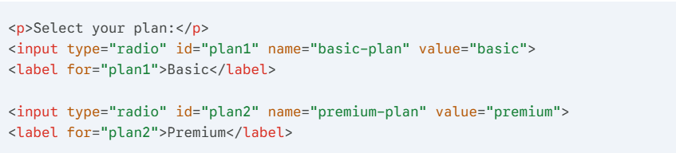
A) They used id instead of class.
B) Radio buttons cannot be used for plans; they should use checkboxes.
C) The name attributes are different. To make them mutually exclusive (only one selectable), the name attribute must be the same for both.
D) They forgot to add the required attribute to the first input.
Answer:

Question 8: A "Hobbies" section for a registration form. Based on the code below, which hobbies will be selected by default when the page first loads?

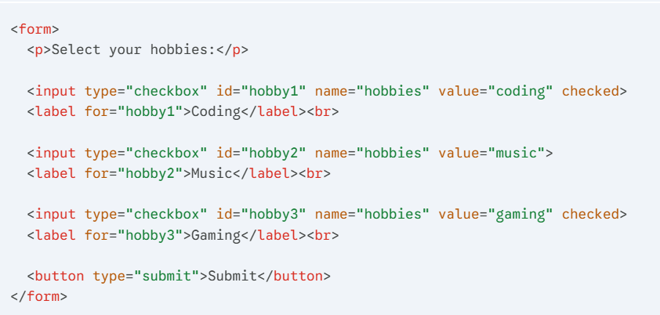

A) Only "Coding" will be selected.
B) Only "Music" will be selected.
C) Both "Coding" and "Gaming" will be selected because they both have the checked attribute.
D) None will be selected until the user clicks them.
Answer:

Question 9: A developer is building a "Dark Mode" toggle for a user settings page. They write the following code and the user clicks the "Save Settings" button. What data will be sent to the server regarding the theme?
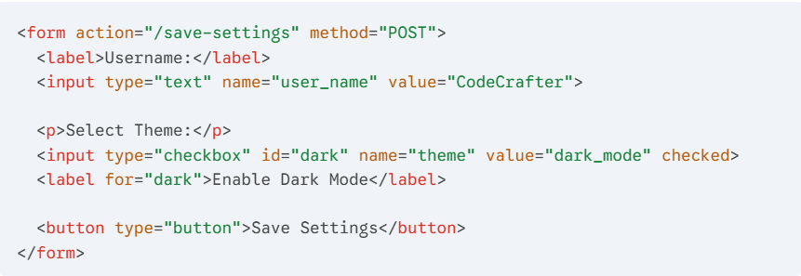
A) user_name=CodeCrafter&theme=dark_mode
B) theme=dark_mode
C) No data will be sent at all.
D) user_name=CodeCrafter&theme=on
Answer:
Question 10: A student is building a "Student Record" table. They want the first cell ("ID Number") to span across two rows. Study the code below carefully. How many <td> tags will be written inside the THIRD row (<tr>) to keep the table aligned?
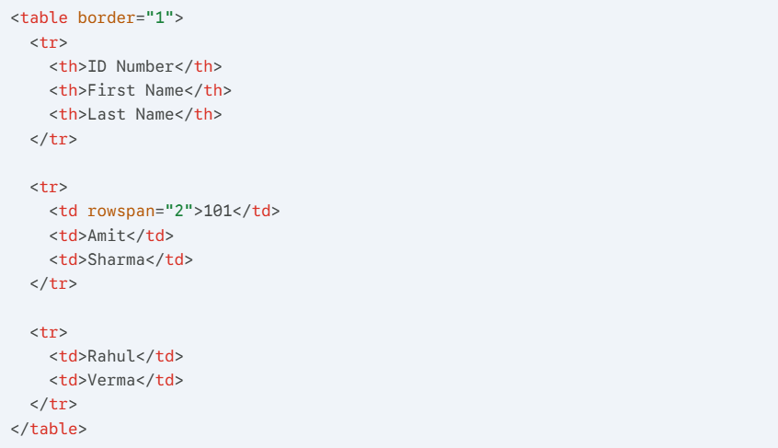

A) 1 Cell
B) 2 Cells
C) 3 Cells
D) 0 Cells (The row is not needed)
Answer:

